Help In Python
--> open python IDLE
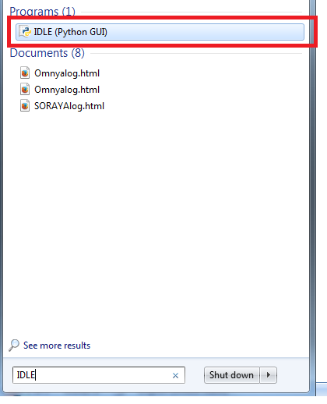
--> to search help for Module
just import this module --> then write help(module)

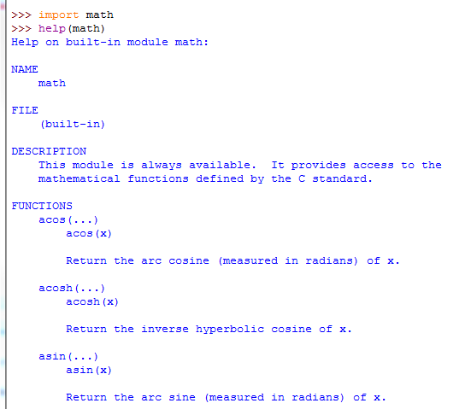

also
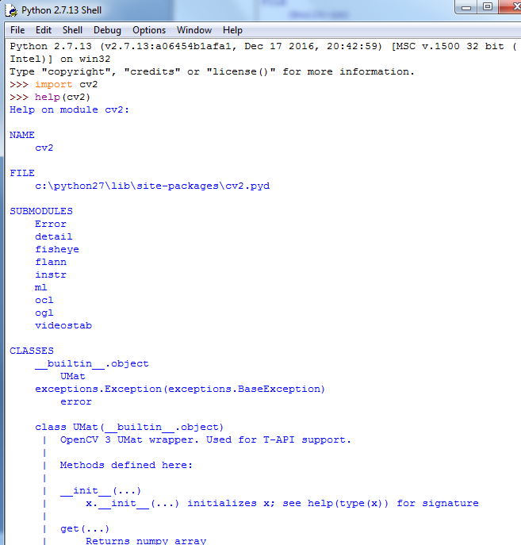

--> to search for specific method or property in a module
1-import module
2-help(module.method)
